Learn Shell Scripting

1-Special_Variables

- $0 - The filename of the current script.|
- $n - The Nth argument passed to script was invoked or function was called.|
- $# - The number of argument passed to script or function.|
- $@ - All arguments passed to script or function.|
- $* - All arguments passed to script or function.|
- $? - The exit status of the last command executed.|
- $$ - The process ID of the current shell. For shell scripts, this is the process ID under which they are executing.|
- $! - The process number of the last background command.|
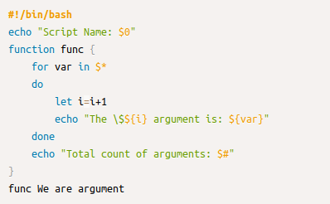
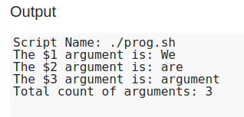

$@ and $* have different behavior when they were enclosed in double quotes.
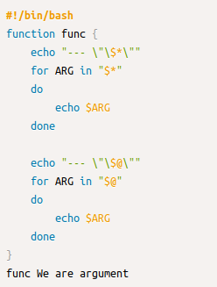
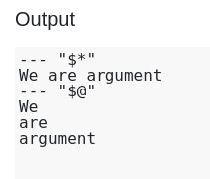

2-trap_command

trap <arg/function> <signal>
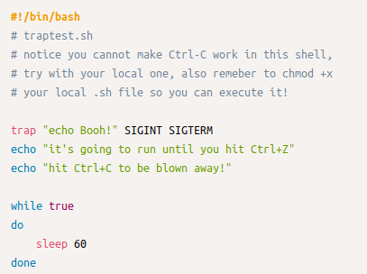

Some of the common signal types you can trap:
- SIGINT: user sends an interrupt signal (Ctrl + C)
- SIGQUIT: user sends a quit signal (Ctrl + C)
- SIGFPE: attempted an illegal mathematical operation
You can check out all signal types by entering the following command:
kill -l
Notice the numbers before each signal name, you can use that number to avoid typing long strings in trap:
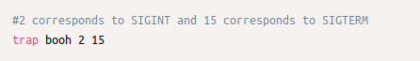

3-File_Testing
The command looks like the following
- -<command> [filename]
- [filename1] -<command> [filename2]

Example
use "-e" to test if file exist
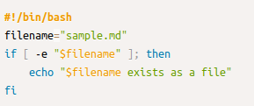

use "-d" to test if directory exists
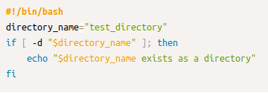

use "-r" to test if file has read permission for the user running the script/test
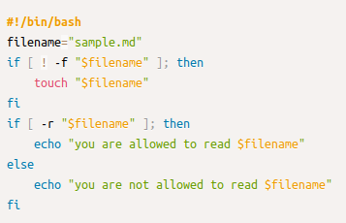

4-Pipelines
A way to chain commands and connect output from one command to the input of the next. A pipeline is represented by the pipe character: |. It's particularly handy when a complex or long input is required for a command.
command1 | command2
By default pipelines redirects only the standard output, if you want to include the standard error you need to use the form |& which is a short hand for 2>&1 |.

5-Process_Substitution
Process substitution allows a process’s input or output to be referred to using a filename. It has two forms: output <(cmd), and input >(cmd).

Example:

Output
Imagine you've two files for which you want to compare the content. Using diff file1 file2 could generate false positives in the case lines are not ordered. So if you want to compare those files you could create two new files, ordered, and compare those. It would look like:
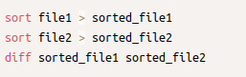

With process substitution you can do it in one line:
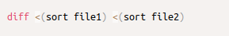

Input
Imagine you want to store logs of an application into a file and at the same time print it on the console. A very handy command for that is tee.


Now let say you want to have only lower case characters in the file but keep the regular case on the output. You could use process substitution that way:

